**Q1**

**Below screenshot shows that my IP is 172.21.74.231 and I have done ssh and then scp to transfer a file.**

**File name is : raj_2.c which has been transferred from Native linux to BBG through scp command.**

**By using the grep command I have shown that my file “raj_2.c” is now available in my BBG.**

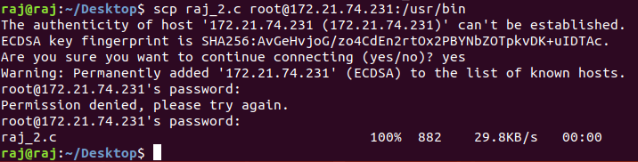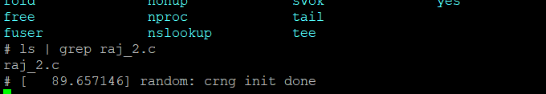

**For below screenshots I have done the same procedure again with a different file name called “raj.c”**

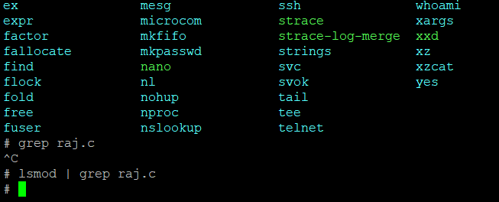

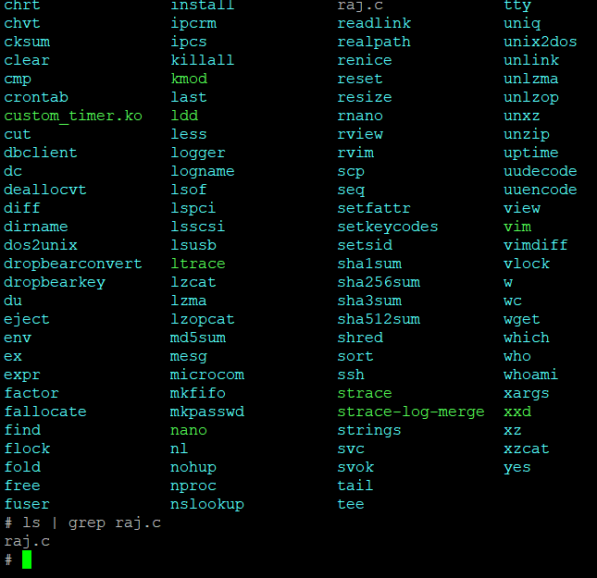

**For below mentioned screenshot I am displaying my common IP address when doing “ifconfig” and also by going into the messages folder in the etc folder and then checking the probing address.**

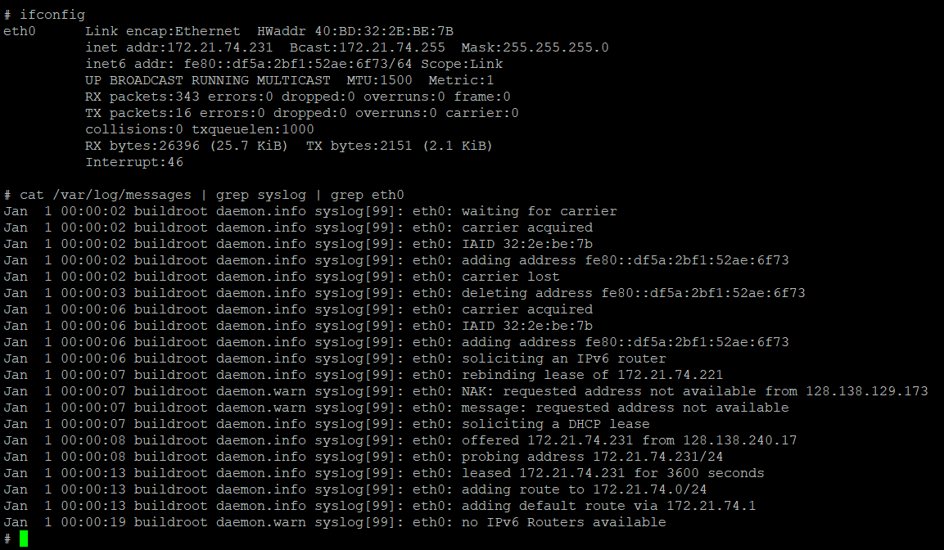

**Q2**

**In this question, I have used one of the .c files which I had used in Assignment 2 Q2**

**I have manually done the debugging and the screenshots are mentioned below.**

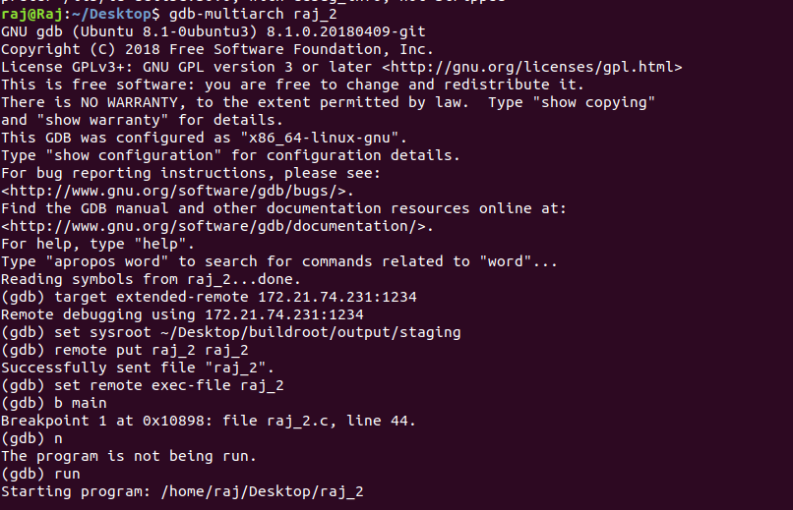

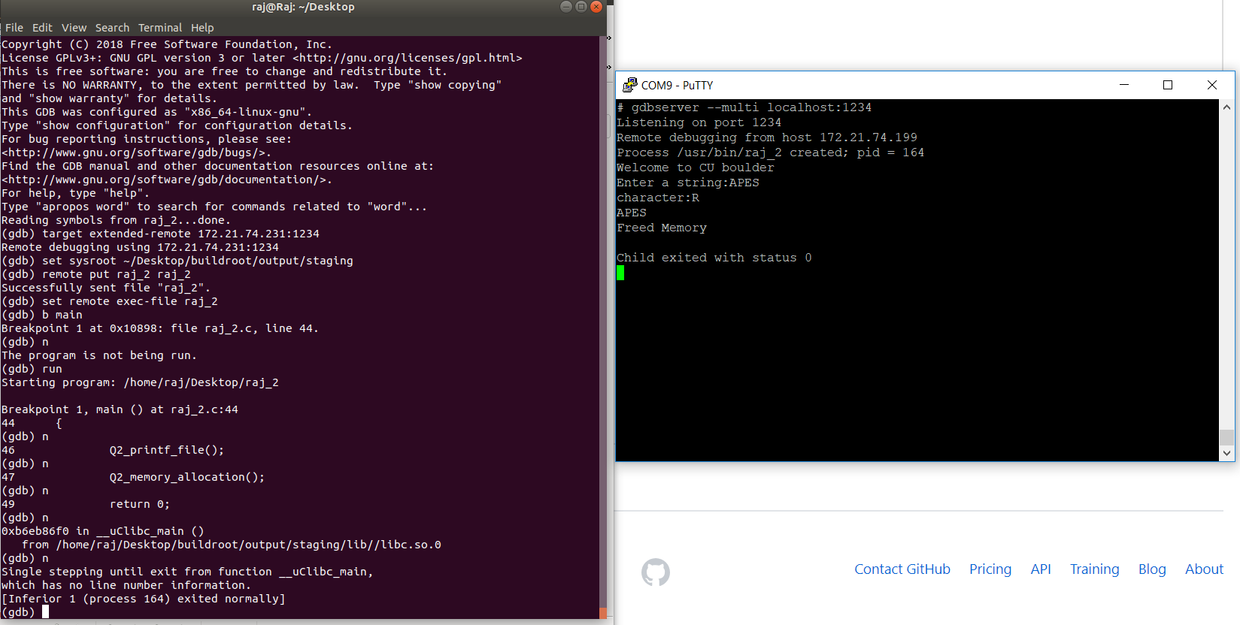

**For the below mentioned screenshots I have ran the commands by running a script and thus I don’t have to do manual debugging. Photo of script is also mentioned below**

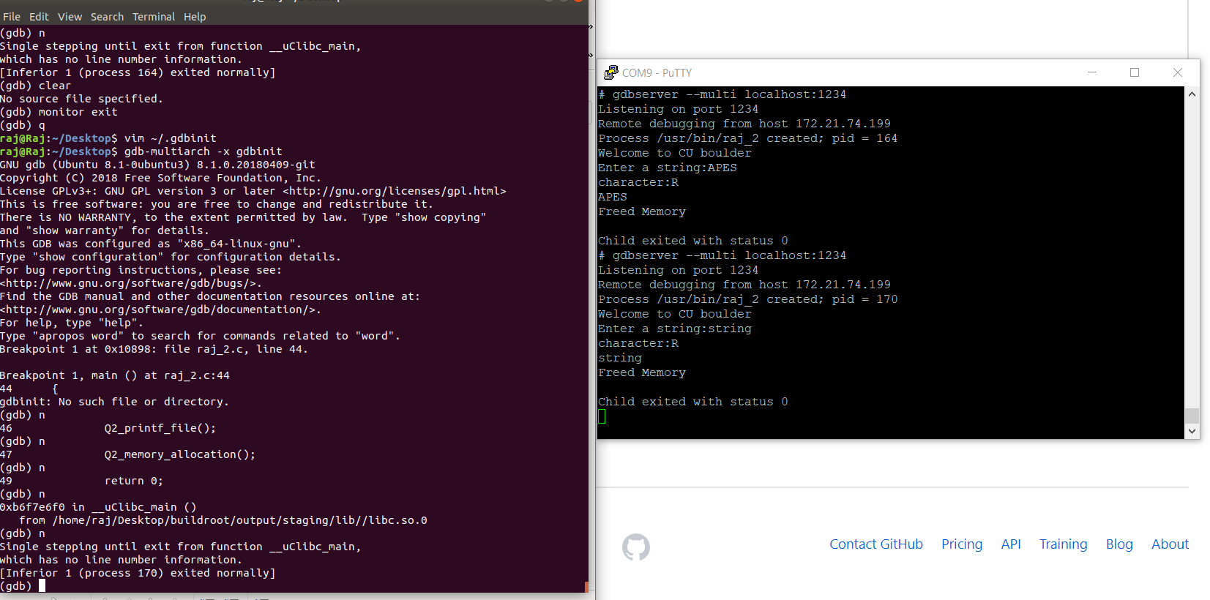

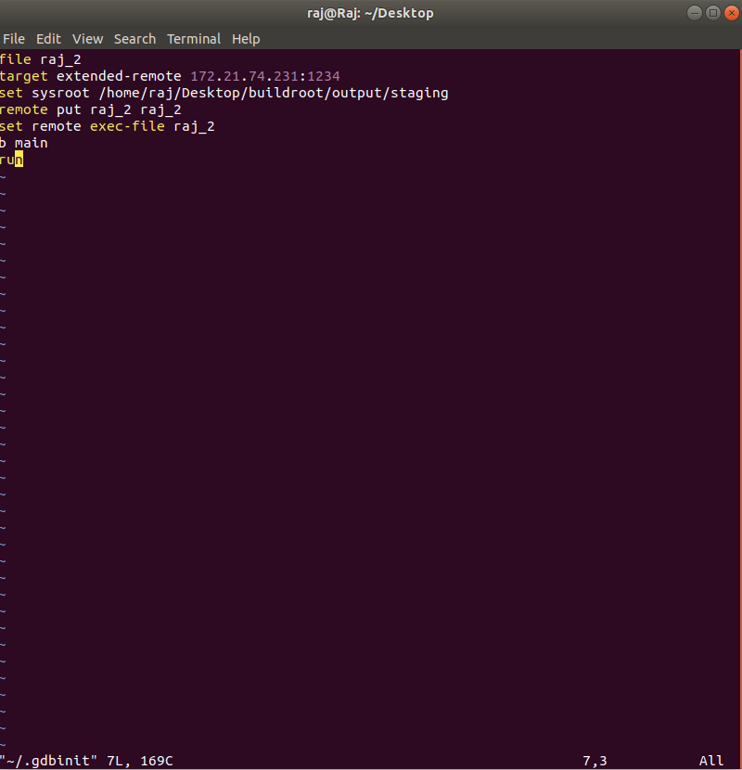

**Q3**

**When I have not put any parameters while initializing the kernel module my default name will be printed as Raj and my default Timer gap value will be 500msec**

**I have written my code in such a manner that the values will be taken in milliseconds**

**The time difference between counter 1 and counter 2 is (63.82-63.32) = 500msec.**

**Thus it can be derived that my default timer value is 500msec**

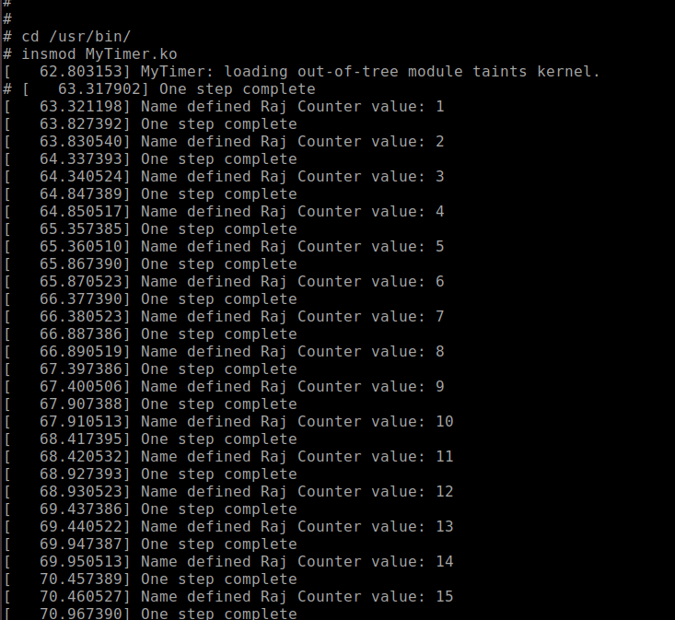

**After that, I gave the parameters and ran the kernel module again. In that I gave the name parameter as “RajLavingiA” and timer gap as = 1000(which indicates 1000ms)**

**The timer difference between Counter 1 and Counter 2 are (187.5-186.49) which indicated that the difference is of 1000 msec. Thus we can say that my defined parameters are working fine.**

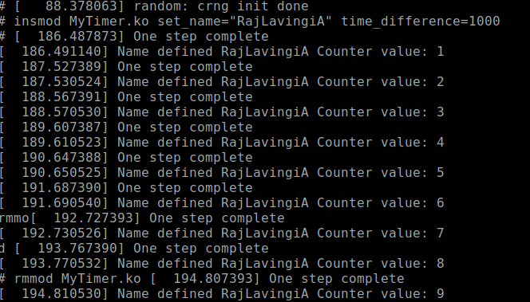

**As per instructions given in the question I have printed the details of My timer by applying command on BBG and the following messages get displayed.**

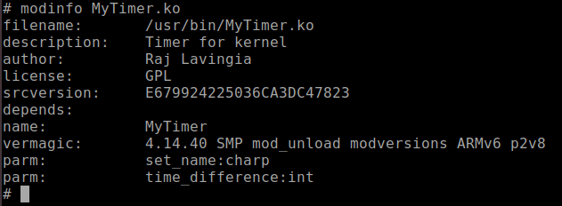

**The following screenshot is of dmesg where you can see the combination of 1st and 2nd screenshot**

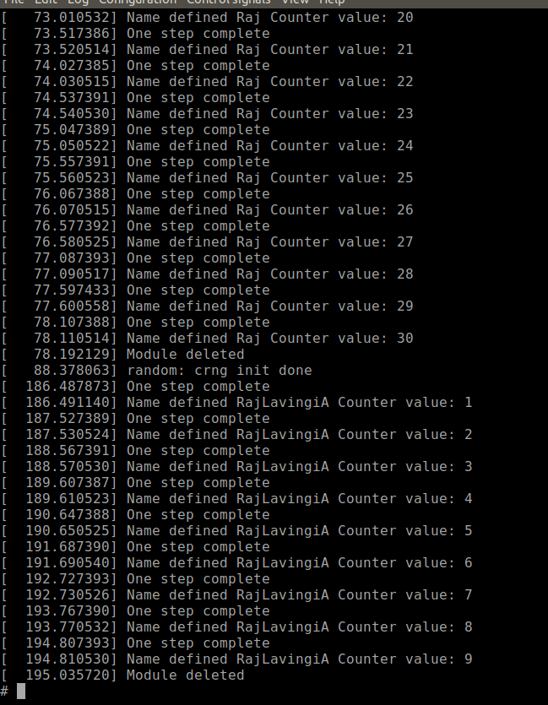

**To initialize a kernel module I have written the command “ insmod MyTimer.ko”**

**After every initialization of kernel module I was using rmmod Mytimer.ko to remove my already made kernel.**